# 



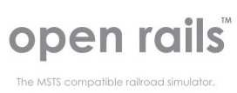

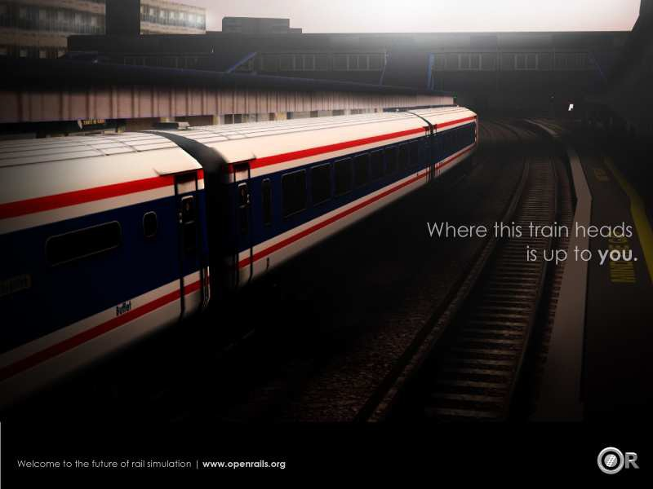

Localization Manual

# Legal

### Warranty

NO WARRANTIES. openrails.org disclaims any warranty, at all, for its Software. The Open Rails software and any related tools, or documentation is provided “as is” without warranty of any kind, either express or implied, including suitability for use. You, as the user of this software, acknowledge the entire risk from its use. See the license for more details.

### Trademark Acknowledgment

Open Rails, Open Rails Transport Simulator, ORTS, Open Rails trademark, openrails.org, Open Rails symbol and associated graphical representations of Open Rails are the property of openrails.org. All other third party brands, products, service names, trademarks, or registered service marks are the property of and used to identify the products or services of their

respective owners.

### Copyright Acknowledgment and License

©2009-2014 openrails.org This document is part of Open Rails.

Open Rails is free software: you can redistribute it and/or modify

it under the terms of the GNU General Public License as published by

the Free Software Foundation, either version 3 of the License, or

any later version.

You should have received a copy of the GNU General Public License

as part of the Open Rails distribution in Documentation\Copying.txt.

If not, see <http://www.gnu.org/licenses/>.

# Contents

Legal 2

Warranty 2

Trademark Acknowledgment 2

Copyright Acknowledgment and License 2

Contents 3

1. Introduction 4

2. Requirements 5

3. Create a new language file 6

4. Update a language file 7

5. Compile the PO file 8

# Introduction

This manual will present how to translate Open Rails.

# Requirements

You need:

* Visual C# 2008 Express
* .Net Framework 3.5
* A Gettext-compatible translation software (for example: POEdit).

The .Net Framework must be in your PATH environment variable.

It is located at:

* C:\Windows\Microsoft.NET\Framework for 32 bit computers
* C:\Windows\Microsoft.NET\Framework64 for 64 bit computers

In POEdit, you will have to disable the generation of MO files (they are useless for Open Rails).

Open the File >> Preferences menu.

In Editor, disable “Automatically compile .mo file on save”.

# Create a new language file

With POEdit, click on “Create new translation”.

Select the POT model. It is located at : Source\Locales\Menu.pot

Sometimes, there are errors when you load the model.

Select the language of your translation file.

Save the PO file in Source\Locales\Menu.

You can now translate the strings with POEdit.

In order to be a lot quicker, you can:

* Go to the next sentence: Ctrl + Enter.
* Copy the source text: Ctrl + B.

Save your modifications and compile the language file (5th chapter of this document).

You also need to add the language to the list of Open Rails. With Visual C# 2008 Express, open Source\Menu\Options.cs in Designer mode.

Select the Language combo box. Click on the “…” icon in Data >> Items.

Add the name of your language to the list (in a new line).

And compile the game.

# Update a language file

When developers add new strings to the game, they will have to update the model. They have to use GNU.Gettext.Xgettext.exe in the 3rdPartyLibs directory.

In the Source directory, you have to use this command:

GNU.Gettext.Xgettext.exe -D ..\Source\Menu\ -D ..\Source\ORTS\Menu\ --recursive -o ..\Sources\Locales\Menu.pot

Then, you must update your PO file. In POEdit, open Catalogue >> Update from POT file.

Select the new POT file.

You will now have the new strings.

# Compile the PO file

The PO file is not readable by Open Rails. You have to generate an Assembly file.

In the Program directory, use this command:

..\Source\3rdPartyLibs\GNU.Gettext.Msgfmt.exe -l fr -r ORTS.Menu -d . -L GNU.Gettext.dll ..\Source\Locales\Menu\fr.po

Replace fr by your language code (“en” for English, “de” for German, etc.).